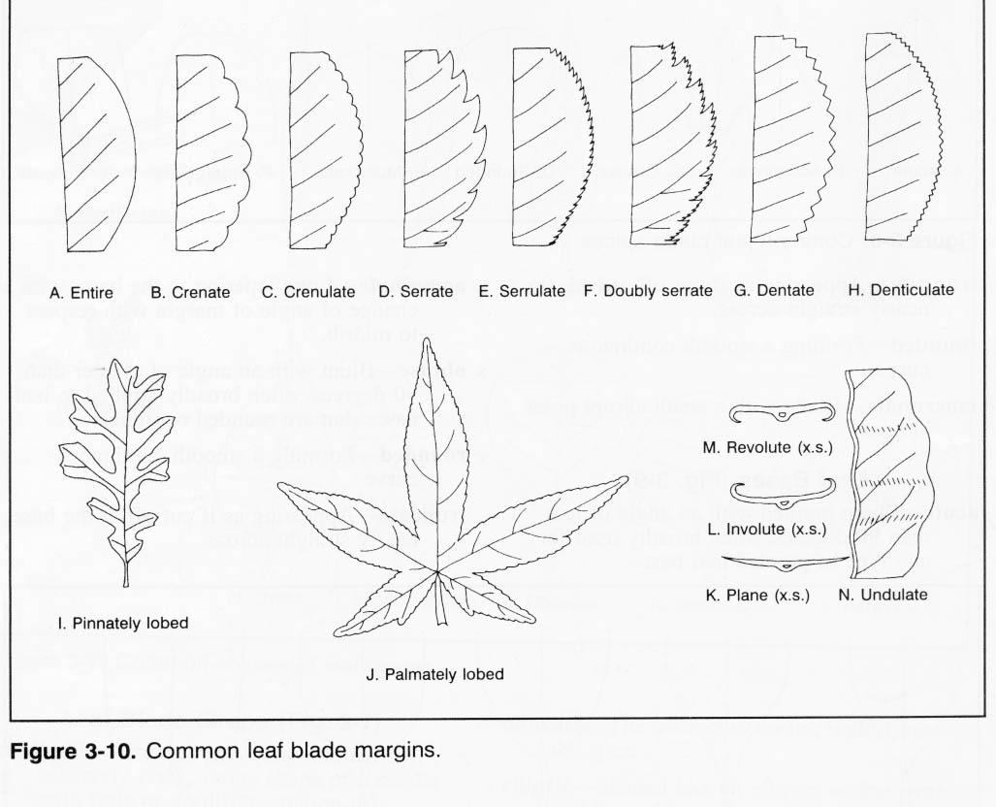HAS IT A _________________ MARGIN?

SERRATE

ENTIRE

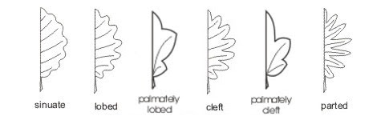DENTATE

LOBED



YES, IT HAS NO, IT HAS NOT

IS IT ______________ ?

RED

ORANGE

YELLOW

BROWN

GREEN

YES, IT IS NO, IT IS NOT